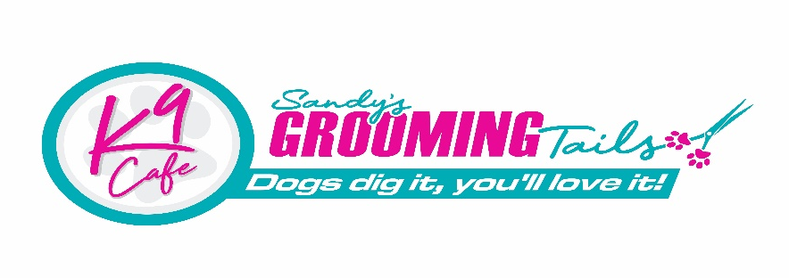

Grooming Salon Terms & Conditions:
By booking and attending your appointment you agree to the following salon policies, procedures, terms, and conditions of The Salon at Sandys Grooming Tails & K9 Café
The Salon/Shop
• All dogs must be on a lead when entering Sandys Grooming Tails & K9 Cafe.
• Please ensure your dog has toileted before entering the salon
• Abuse, in any form, to management and/or staff will not be tolerated and will result in refusal of service.
• Dog owners are responsible for the actions of their dogs and must be respectful of other dogs and customers
Pricing
Payment is due on job completion.
• All prices, given over the phone or without having personally assessed your dog, are an estimate only and are subject to change at groomers discretion.
• Extra charges may apply due to excessive matting, extra time grooming or stylised trims.
• Extra charges may apply for flea treatments where needed.
• Extra charges may apply for difficult behaviour.
• Extra charges may apply for excessive cleanup of excrement.
Bookings
A pattern of “No Shows” or repeat last minute cancellations may be asked to pay a non-refundable upfront deposit of $50 on future bookings.
Late Collection:
Additional charges may be incurred for the unarranged late collection of the pet. The owner must notify the salon team if they are unable to collect their pet within regular business hours.
Charges from $15 per 15 mins will be incurred where after hours care is required.
In the event the pet is uncollected by close of business and contact cannot be made with the owner or the emergency contact, the local council will be contacted to arrange collection.
Completion Time:
Every effort will be made to keep our scheduled grooms running smoothly. A typical pet(s) groom can be completed in 2 to 4 hours from the time of your appointment. If your pet(s) has behaviour issues or skin and coat problems, you may be looking at a longer period of time. If you need your pet(s) returned by a certain time, please let us know prior to the groom. We are happy to work with you as much as possible.
Grooming:
We reserve the right to modify your dog’s haircut and price in accordance with coat condition (which will be explained to you upon discussing your dog’s groom) i.e.
- If it has been longer than 8 weeks between visits;
• If staff feel no brushing has been undertaken at home in between visits;
• If your dog is matted and staff feel it is cruel and painful for the dog to be groomed out;
• If your dog is matted and staff feel an injury may occur in the process of brushing/combing/de-matting
(this may cause rashes/haematoma’s etc.)
• If your dog is excessively dirty
• If staff notice fleas on your dog, a flea treatment will be given (unless previously stated otherwise by owner)
Whilst we take all due care to ensure no injury occurs during your dog’s grooming visit, IF your dog does sustain an injury as a DIRECT result of the condition of your dog’s coat, we will not be held responsible.
If you are unhappy with your experience at Sandys Grooming Tails we ask that you bring this to our attention ASAP and allow us the chance to resolve the issue.
This is very important especially when lengths of coat are involved e.g. what is short to us may not be short to you

Reactions to products:
Whilst we only use high quality products on your pets, there is always a rare risk that (from no fault of our own) a dog may have a skin reaction/irritation from something we use. Owners MUST inform Sandys Grooming Tails of any and/or all skin issues that their pet/s have or have had in the past.
If concerned about the dog’s sensitivity to products it is the owner’s responsibility to provide Sandys Grooming Tails with an alternative shampoo they would like used instead.
If your dog experiences irritation due to salon products immediately within 24hrs after the groom, please let us know so we can mark this on their record and avoid future discomfort.

Matting:
It is not uncommon to find pre-existing conditions such as hot spots, sores, and other skin issues once the matted coat is removed. There is also a chance that your pet’s skin may become irritated from clipping so close due to matting and could be accidentally cut in the process. The procedure takes extreme care and extra time, due to this there will be additional charges depending on the severity of the matting.

Double coat shave down:
Understand that Sandys Grooming Tails does not recommend shaving a double coated dog and only condones this practice as a last resort or in exceptional circumstances for the welfare of the pet.
The associated risks (listed below) if chosen to proceed, are as follows:
1. The dog’s coat may not grow back after shaving
2. The dog may require sunscreen to protect their skin from being burned
3. Shaving may cause irritation and/or a rash
4. A double coat acts as insulation in both warm and cold weather and shaving may not make the dog feel cooler
5. Shaving does not reduce the amount of shedding, just the length of the fur that sheds
6. Depending on the dog’s coat type and the length requested, clipping down a double coat can look uneven and choppy

Health:
In the unlikely event that, veterinary treatment is required which has an imminent impact on a pet’s health, the owner gives consent for this establishment to seek treatment for the pet at the closest local veterinary clinic.
The owner will be contacted as soon as possible to advise of any incident or condition noticed or occurring during the service. The service will not be completed until either; the owner is contacted and permission to continue is granted or consent obtained and recorded for veterinary assessment, with the owners aware of any costs that may be involved.
We are not liable for any vet related costs due to health issues arising from pre-existing medical
conditions such as:
• Matted coats which may result in clipper rash, minor nicks, and cuts
• Exposing pre-existing hot spots and sores.

Safety & Welfare:
Grooming can be a stressful experience for some pets. To help us ensure the safety and welfare of the pet, the owner (or authorised person) must inform the salon staff of the following:
• If the pet has a heart condition or a pre-existing medical condition, illness, or injury.
• If the pet is recovering from a recent surgery.
• If the pet is under any form of sedation. If sedation is required, the customer will be referred to a vet clinic.
We will always exercise care when grooming your pets, however we are not responsible for the physical or mental reaction a pet may have whilst being groomed.
The service may be refused or ceased if the service is deemed a risk to the pet or other pet’s health.
Owners may be asked to collect their pet if they present a safety risk to team members, other animals,
or themselves. Sandys Grooming Tails may exercise refusal of future service if deemed unsafe, or too hard to handle.

Older Dogs:
We will use extra care and patience for older pet(s)s; however, we will not be held responsible for
any reaction due to the mental or physical stress of grooming the geriatric pet(s). If, in our judgment,
brushing or clipping is determined to cause too much stress to the pet(s), we will modify or terminate
the haircut. Please be sure to notify us of any health conditions that might make your pet(s)
uncomfortable during the bathing, drying, or clipping phases.
Any grooming which takes place on an elderly or frail pet(s)/s is conducted at your risk.

Aggression:
Pets that display aggression towards the groomer or other dogs will be separated and muzzles used, if deemed necessary.
Owners may be asked to collect their pet if they present a danger to team members, other animals, or themselves.

Vaccination:
It is recommended that puppies received their vaccinations 10 days prior to attending the salon.
It is recommended that dogs vaccinations are up to date.
We have strict cleaning protocols in place to reduce the risk of spreading disease.
We are NOT be liable for any vet related costs due to illness in unvaccinated pets.

